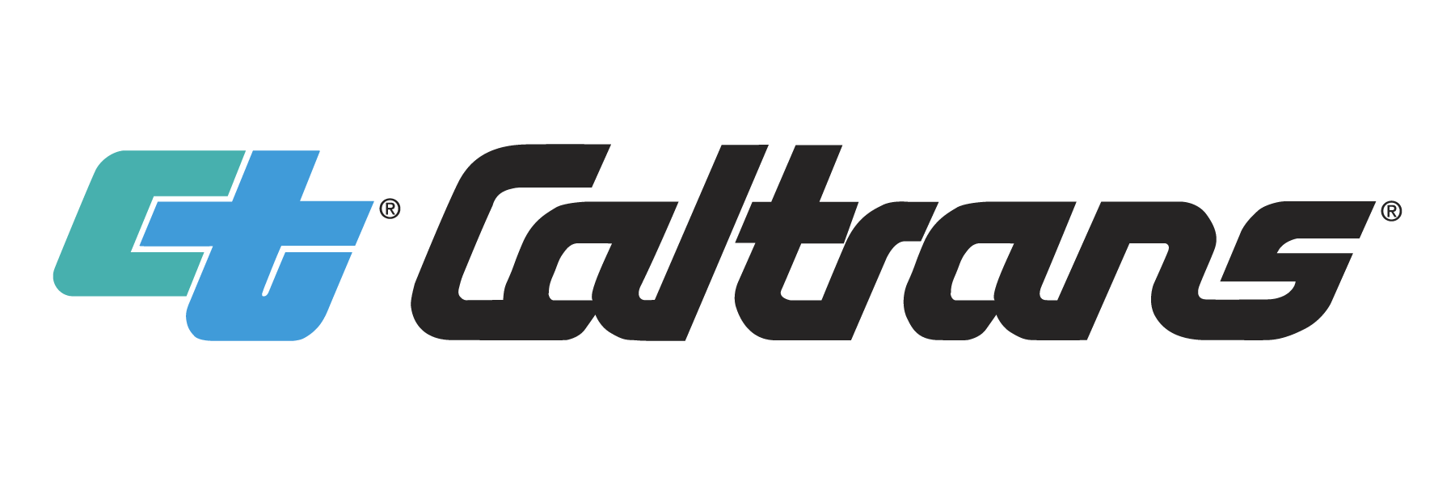

Visual Impact Assessment Memorandum

{Scenic Resource Evaluation}

[This VIA Memo outline can be used for Scenic Resource Evaluation – complete Section 6 and add to title: Scenic Resource Evaluation]Annotated Outline

Prepared by: _________________________________ Date:
[Insert Name]
[Insert Company Name if appropriate]
[Insert License # if appropriate]
[Insert {Project Landscape Architect or Project Landscape Associate} for Caltrans] documents]

Approved by: _________________________________Date:
[Insert Name]
[Insert License #]
Caltrans District Landscape Architect
[Insert Office or Branch]
[Insert District #]
Statement of Compliance: Produced in compliance with National Environmental Policy Act (NEPA) and California Environmental Quality Act (CEQA) requirements, as appropriate, to meet the level of analysis and documentation that has been determined necessary for this project.
Per Exhibit D, Article XVIII, Section A. (1) of the contract: (c) 2020 California Department of Transportation. [Include for consultant prepared documents]

[It is optional to include a Table of Contents, based on the length of the Memorandum VIA report and amount of detail. Use the “Update Table” feature to ensure any subsections added are listed in the Table of Contents and page numbering is accurate.]
Table of Contents
1 Introduction 1
1.1 Purpose of Report and Assessment Methodology 1
2 Establishment Phase 1
2.1 Project Location and Setting 1
2.2 Project Description 2
2.3 Description of Area of Visual Effect 2
2.4 Visual Resources and Scenic Resources 2
3 Inventory Phase 2
3.1 Description of Landscape Visual Character 2
3.2 Description of Landscape Visual Quality 2
3.3 Viewers 2
3.4 Viewpoints 3
4 Analysis Phase 3
4.1 Evaluation of Visual Impact 3
5 Mitigation Phase (Environmental Commitments) 3
5.1 Recommendations for Environmental Commitment Measures 3
6 Scenic Resource Determination 4
7 Conclusions 4

List of Appendices
Appendix A: Scoping Questionnaire

[Lists of Figures and Tables shown below are for example only. Add additional figures or tables in the order they appear in the text, including appropriate page numbers.]
{List of Figures
Figure 1: [Title] 3
List of Tables
Table 1: Summary of Environmental Commitments 3}

[List of Acronyms and Abbreviations shown below is for example only. Add or remove additional acronyms or abbreviations as necessary for the clarity of the memorandum VIA. Arrange additional acronyms or abbreviations in alphabetic order.
Use the list below with project specific updates]
List of Acronyms and Abbreviations
{AVE Area of Visual Effect
Caltrans California Department of Transportation
CEQA California Environmental Quality Act
Handbook Caltrans 2023 VIA Handbook
FHWA Federal Highway Administration
NEPA National Environmental Policy Act
PDT Project Development Team
VIA visual impact assessment}

[The following text is guidance only, to be removed once this document is completed:
This Visual Impact Assessment memorandum should be concise and defensible. Define the visual environment and analyze the project’s aesthetic components and its potential to integrate within its location and setting. The purpose of a memorandum-level VIA is to address visual impacts of a proposed project that are of a very limited or minimal nature, and to provide recommendations to reduce the visual impact and improve the aesthetic conditions. If appropriate, consider the use of maps, project drawings, and project area photographs from key viewpoints with captions to support the narrative and to provide context for the memorandum and justify the findings. A completed Visual Resource Questionnaire should be attached to Appendix A of this memorandum.]
[Information Regarding the Use of This Report Template
This annotated outline contains three types of text:
Black text boilerplate and should be used in the document but may be edited as necessary for the project.
[Blue text] in square brackets consists of instructions, guidance, or sample text that should be replaced with project-specific information. Delete all unedited blue text once the document is finalized.
{Red text} in curly brackets indicates the options to select the correct word or phrase for completing a sentence.

Introduction

Purpose of Report and Assessment Methodology
The purpose of this visual impact assessment (VIA) memorandum is to document potential visual change in the Area of Visual Effect (AVE). This memorandum follows the guidance outlined in the publication Guidelines for the Visual Impact Assessment of Highway Projects, published by the Federal Highway Administration (FHWA) in January 2015. The formatting of this template is aligned with the directions and examples included in the Caltrans 2023 VIA Handbook (Handbook), available at: [insert website link]

Establishment Phase

Project Location and Setting
The project location and setting provide the context for determining the type of changes to the existing visual environment. The proposed project is on [insert route type and number] between [insert northern or western project termini] and [insert southern or eastern project termini] in the [insert name of municipality] in [insert name] County, California. The project is in [insert general biogeographical or ecological name of the region] of [northern, southern, central, or other commonly understood geographic location] California.
The landscape is characterized by [insert a short summary description of landform and land cover].

Project Description
The project proposes to [add a succinct description of what will be built, emphasizing the visible changes to the transportation system. Describe the aesthetic features and elements that are designed and planned for the project. Where applicable, describe how the project design accounted for potential benefits and/or impacts and how to avoid or minimize visual impacts that were adopted early in the project development process.]

Description of Area of Visual Effect
[Describe the AVE and, if appropriate, attach a map showing the area of the Proposed Project Action/Build and/or Alternative(s). The map should be appropriate for the project and consistent with other NEPA/CEQA technical memoranda and technical reports. Refer to Handbook Section 2.5.]

Visual Resources and Scenic Resources
[If appropriate, add text describing any scenic resources and/or visual resources found in the Project corridor. If such resources exist, indicate whether any portion of the project is within a designated State Scenic Highway or a highway eligible for designation, and why there is no impact on the scenic and/or visual resources. Refer to Handbook Section 2.4.]

Inventory Phase

Description of Landscape Visual Character
[Briefly describe the setting within the AVE in terms of landscape visual character (refer to the Handbook Section 3.2). Describe how the proposed project influences the natural, cultural, and project environments positively or negatively.]

Description of Landscape Visual Quality
[Briefly describe the setting within the AVE in terms of landscape visual quality (refer to the Handbook Section 3.4) Consider the intactness, unity, and vividness of natural, cultural, and existing visible project environments.]

Viewers
Neighbors (people with views to the transportation project), travelers (people with views from the transportation project) and viewpoints {will or will not} be affected by the proposed project.
[Describe, using and explaining the concepts of viewer and viewpoint sensitivity (refer to the Handbook Sections 4.5 and 4.6), how these two visual qualities will or will not be impacted by the proposed project.]

Viewpoints
Viewpoints can be vistas, open landscape views, ocean views, views of important mountains, views of historic or attractive buildings, rock outcrops, heritage trees, tree groves etc. The importance of each viewpoint is determined by the level of scenic resource designation, the distance of the scenic or visual resource, and the visual quality of the scenic or visual resource. The scoring requires a narrative and you must include a descriptive rank, and a numeric rating.

Analysis Phase

Evaluation of Visual Impact
[Insert a brief narrative detailing visual change, based on visual compatibility and contrast of the proposed project with the existing environment, and visual sensitivity, based on viewer and viewpoint sensitivity. Characterize the overall visual impact of the project as none, low, moderately, or highly beneficial or low, moderately, or highly adverse. Address each of the CEQA Checklist Aesthetics questions listed below:
Would the project:
a) Have a substantial adverse effect on a scenic vista?
b) Substantially damage scenic resources, including, but not limited to, trees, rock outcroppings, and historic buildings within a state scenic highway?
c) In nonurbanized areas, substantially degrade the existing visual character or quality of public views of the site and its surroundings? (Public views are those that are experienced from publicly accessible vantage point). If the project is in an urbanized area, would the project conflict with applicable zoning and other regulations governing scenic quality?
d) Create a new source of substantial light or glare which would adversely affect day or nighttime views in the area?
However, do not make a determination of significance in the VIA, this will be determined by the Project Development Team (PDT) and addressed in the environmental document. Also discuss any potentially controversial project features, such as noise barriers, or tree removal.]

Mitigation Phase (Environmental Commitments)

Recommendations for Environmental Commitment Measures
Environmental commitments have been proposed to lessen the visual impact of the project, which may also help generate public acceptance of a project. Environmental commitments will be designed and implemented with the concurrence of the District Landscape Architect.
The following environmental commitments can avoid or minimize negative visual effects and/or improve aesthetics:
[Insert name of environmental commitment and include design options if appropriate. Measures should be clear, concise, constructable, and biddable. Refer to the Handbook Section 5 for more details. Describe where the commitments are in the project setting and how the commitment may vary in different locations. Indicate for which alternatives and visual impacts this measure will be applied. Repeat as necessary.]

Scenic Resource Determination
[Delete this paragraph if this outline is being used to complete a VIA. If this outline is being used for a Scenic Resource Evaluation, provide a narrative describing Scenic Resource findings here. More information on the CEQA requirements for Scenic Resource Evaluation is included in Chapter 27 of the SER].

Conclusions
[Insert if appropriate and add any concluding remarks if applicable.]

Appendix A: Scoping Questionnaire

