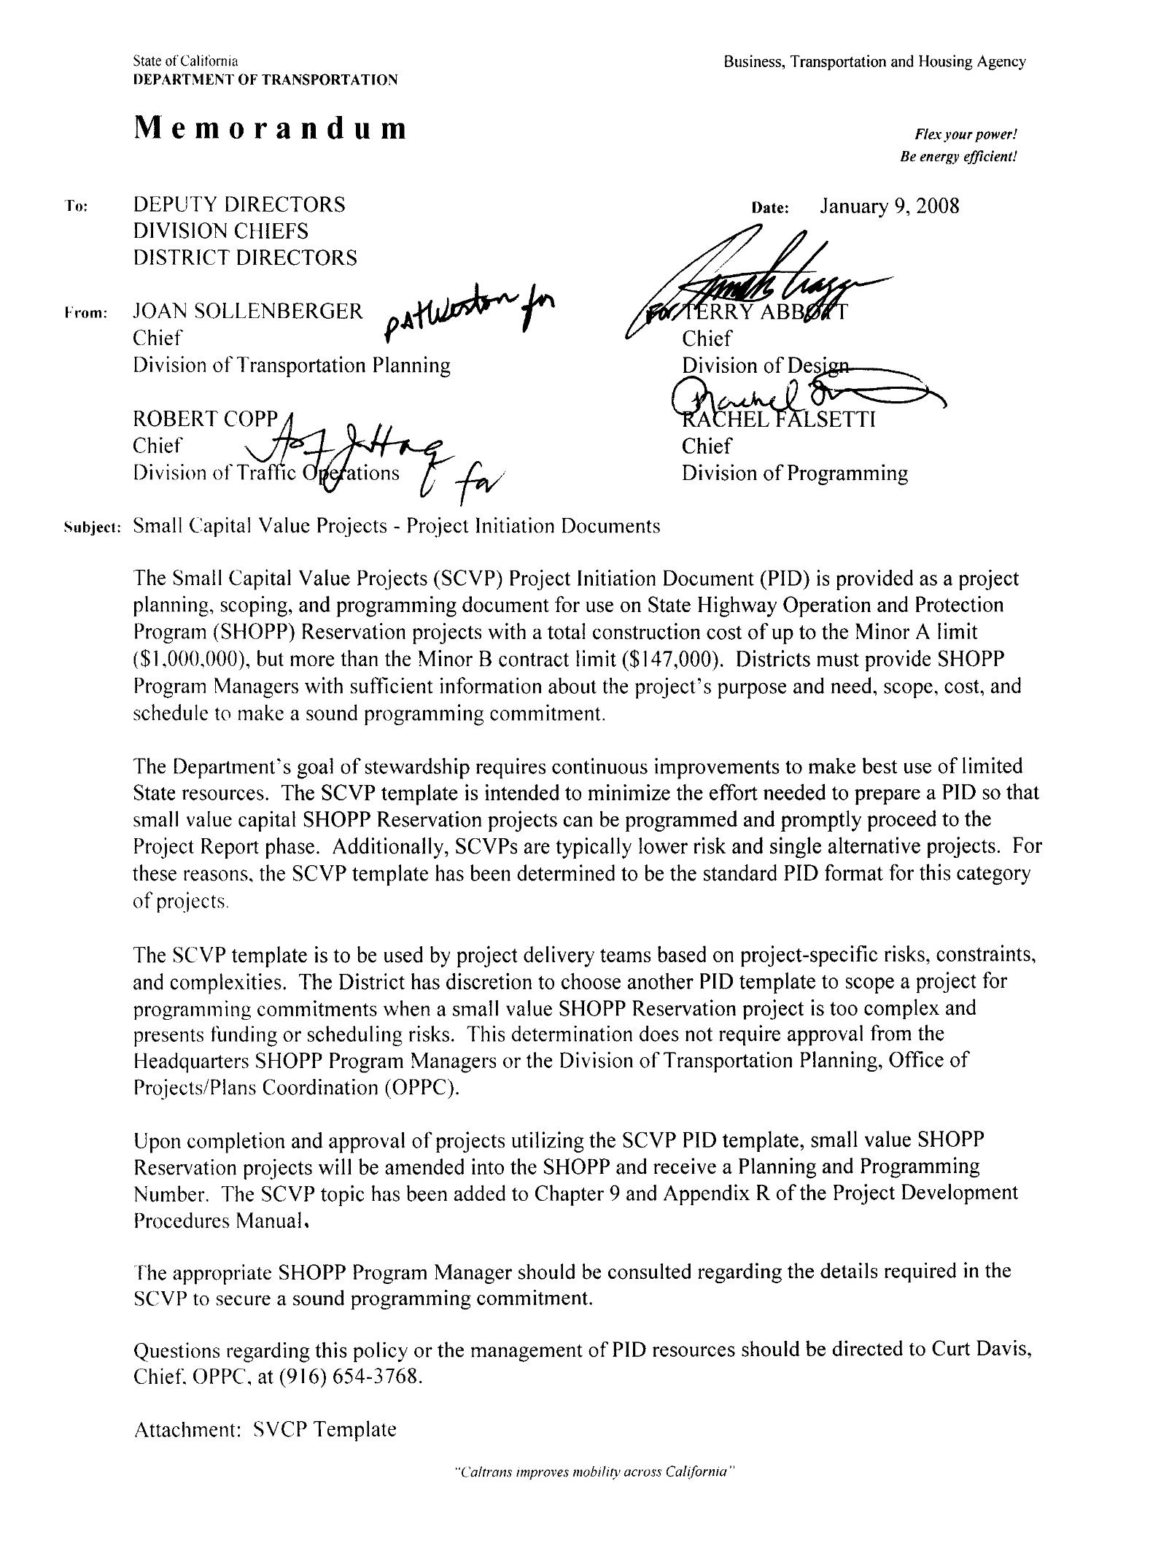

[SCVP Template](http://www.dot.ca.gov/hq/oppd/pdpm/templates/apdx_r.doc)

January 9, 2009