Caltrans Construction Safety Award Program (CCSAP) Fact Sheet

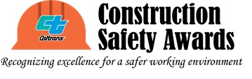

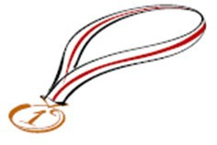
Show that you’re committed to improving safety for construction projects…

Apply for a 2024 Caltrans Construction Safety Award!
The CCSAP has two annual awards: the “Safety Excellence Award”, and the “Safety Innovation Award”. The “Safety Excellence Award” recognizes project teams who show superior performance in safety and who go above the minimum safety requirements of the contract. The “Safety Innovation Award” recognizes projects with innovative technology, work methods, products, materials, and safety improvements that resulted in a safer work environment.

The following table is applicable to both award categories/types.
Project Type  (Major Project  only): | Completed | On-going
 | Statewide recognition for projects  completed (approved Proposed Final Estimate (PFE) or Interim PFE or exceptions to PFE where the work is completed, or contract items completed with the exception of plant establishment period) between July 1, 2022 and August 31, 2023 | District recognition for on-going  projects (75% progress payment by August 31, 2023)
Recognition  Level: | Platinum, Gold, and Silver awards
What you get: | - Recognized at the annual awards ceremony, part of the 2024 Caltrans and Industry Safety Summit  - Certificates (Caltrans, Contractor, & Subcontractors if applicable)  - Reflective hard-hat “Award Winner” stickers (TBA)  - Hard Hat Stress Relievers (TBA)  - Hard Hat Safety Awards (2 per project:  1 to the Caltrans RE and 1 to the contractor’s PM) (TBA) | - Recognized at District meeting  - Certificates (Caltrans, Contractor, & Subcontractors if applicable)  - Reflective hard-hat “Award Winner” stickers (TBA)  - Hard Hat Stress Relievers (TBA)

How Do You Apply?

Download the application online at https://dot.ca.gov/programs/construction/CCSAP. Applications are due to the HQ CCSAP Manager (for completed project) or the District CCSAP Coordinator in the district where the contract is administered (for ongoing project) by September 29, 2023. The link to the current CCSAP Contacts can be found at: https://dot.ca.gov/programs/construction/ccsap/ccsap-contacts.

Frequently Asked Questions (FAQs)

Please refer to the FAQs document posted on the main page for the CCSAP at:

https://dot.ca.gov/programs/construction/ccsap

